- AdBlue (DEF) Level and System Fault Warnings with RTT_Fixed TT

– EU S-Family specific for 2018 V362MCA/C519 CGEA1.3

Functional Description

The purpose of the AdBlue (DEF) Warnings with RTT/Fixed TT is to inform the vehicle operator that Diesel Exhaust Fluid level is low or there is a system fault on diesel vehicles equipped with SCR emissions system. Note AdBlue is a trademarked name for Diesel Exhaust Fluid (DEF) and for EU the AdBlue Text/RTT/TT is used vs. DEF Text/RTT/TT which is used in other markets.

This feature correlates the VehUreaRnge2_L_DsplyMx signal, VehUreaRnge3_L_DsplyMx signal, UreaLvlTxt_D_RqDsply signal, UreaQltySys_D_RqDsply signal, UreaQltyFlg_B_RqDsply signal, UreaMnAdd_L_Actl or UreaMnAdd_L2_Actl signal, the Display_Units_MC Flag, the DEF Warnings configuration bit, the Internal Supplier Config Bits (Full Tank DEF Range, UreaMinAdd Signal Usage), and the Operational Mode to illuminate or extinguish the AdBlue Telltale, RTT, message center messages & chime for the specific condition as appropriate.

Note this program specific STSS uses both the UreaMnAdd_L_Actl (old signal) and UreaMnAdd_L2_Actl (new signal) controlled by internal supplier configuration bit because ECM could not support phase in of the new signal on all programs supported by this STSS. The internal supplier config bit is required because common IPC software is used throughout.

The AdBlue Telltale or RTT shall provide an iconic representation that will illuminate, extinguish to inform the driver of certain DEF system conditions.

This section describes the AdBlue RTT / Warning / Info Screen function and sets various flags that are used by the Message Center display and Chime Arbitrator (See Message Center Section for details of Message Display Algorithm and Chime arbitrator section).

This feature shall be incorporated on ALL diesel vehicles as per PDL, however, this feature shall be configured OFF for those diesel applications where local market regulations do not require this feature. This feature is not to be implemented on gas engine vehicles.

This STSS supports EU function ONLY and employs a set of AdBlue text messages and AdBlue RTT/TT.

Full Tank DEF (AdBlue) DTE (range):
Version 3.0 of this STSS introduces Full tank DEF DTE (range). This feature uses VehUreaRnge3_L_DsplyMx to display DEF range from full tank down to where inducement⁽¹⁾ starts. Upon starting the regulated inducement (2400 km) the range is displayed based on the value of VehUreaRnge2_L_DsplyMx signal. The design is implemented this way because powertrain did not want to modify the regulated inducement relative to this feature. Other notes relative to Full Tank DEF DTE:
- Initial agreement and intent will be to decrement the Full tank DEF DTE in increments of 100km or 100mi. ECM to send out VehUreaRnge3_L_DsplyMx in 100 unit increments.
- VehUreaRnge3_L_DsplyMx signal is unitless. ECM shall determine whether the vehicle is in English or Metric mode and send out VehUreaRnge3_L_DsplyMx as either kilometers or miles.
- IPC shall display the value of VehUreaRnge3_L_DsplyMx signal in km or miles based on whether the vehicle is in English or metric units. For Full Tank DEF DTE IPC does not do the units conversion.
- The function relative to VehUreaRnge2_L_DsplyMx signal is unchanged and IPC shall display a countdown range in kilometers or miles and perform the conversion from kilometers to miles as has been done in the past.
- Full Tank DEF DTE is enabled per internal supplier configuration bit to assist in roll out and allow feature to be turned off if technical issues arise.

- Inducement is all of the function not including the Full Tank DEF DTE and the DEF Level Ok/Under ½ Full on demand screens. The Inducement function is regulated and intended to meet CARB/EPA requirements relative to DEF Level and Fault indication.

Interfaces

Interface Context Diagram (I/O Block Diagram)
Figure 1 Diesel Exhaust Fluid Level Indication
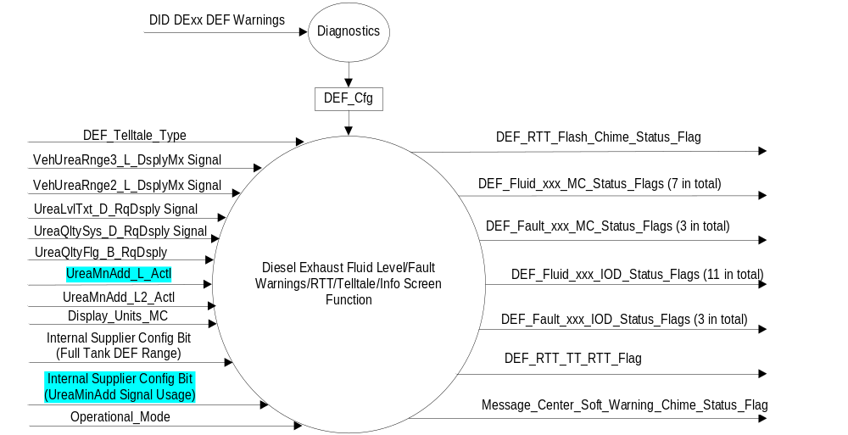

Inputs
      - INTERNAL:
    - Operational_Mode
    - DEF_Telltale_Type
    - Internal Supplier Config Bit (Full Tank DEF Range): 0x0 = Disabled, 0x1 = Enabled
    - Internal Supplier Config Bit (UreaMinAdd Signal Usage): 0x0 = use UreaMnAdd_L_Actl, 0x1 = use UreaMnAdd_L2_Actl

      - MUX From ECU

- VehUreaRnge2_L_DsplyMx Signal
Signal Name | Size  (bits) | Detail | Units | Res. | Offset | State Encoded | Min. | Max.
VehUreaRnge2_L_DsplyMx | 12 |  | km/h | 1 | 0 |  | 0 (0x0) | 4095 (0xFFF)

- VehUreaRnge3_L_DsplyM Signal
Signal Name | Size  (bits) | Detail | Units | Res. | Offset | State Encoded | Min. | Max.
VehUreaRnge3_L  _DsplyMx | 16 |  | Unitless | 1 | 0 |  | 0 (0x0) | 65535  (0xFFFF)

- UreaLvlTxt_D_RqDsply Signal
Signal Name | Size  (bits) | Detail | Units | Res. | Offset | State Encoded | Min. | Max.
UreaLvlTxt_D  _RqDsply | 4 |  | Unitless | 1 | 0 |  | 0 (0x0) | 15(0xF)
 |  | Over_Half_Full |  |  |  | 0x0
 |  | Under_Half_Full |  |  |  | 0x1
 |  | Range_XX_miles |  |  |  | 0x2
 |  | Range_X_miles |  |  |  | 0x3
 |  | SpdLmt_Y_MPH_Low |  |  |  | 0x4
 |  | Y_MPH_MAX_ON_restart |  |  |  | 0x5
 |  | SpdLmt_Y_MPH_Empty |  |  |  | 0x6
 |  | MaxMPH_Y_ON_restart |  |  |  | 0x7
 |  | SpdLmt_Y_MPH_XMiles |  |  |  | 0x8
 |  | Eng_Idled_on_refuel |  |  |  | 0x9
 |  | Eng_Idles_on_Manual |  |  |  | 0xA
 |  | ZZ Overides available upon Restart |  |  |  | 0xB
 |  | SystemError |  |  |  | 0xC
 |  | Undefined |  |  |  | 0xD–0xF

- UreaQltySys_D_RqDsply
Signal Name | Size  (bits) | Detail | Units | Res. | Offset | State Encoded | Min. | Max.
UreaQltySys_D  _RqDsply | 3 |  | Unitless | 1 | 0 |  | 0 (0x0) | 15(0xF)
 |  | No quality problem or system error |  |  |  | 0x0
 |  | CONTAMINATED exhaust fluid, SPEED LIMITED YY mph in XX mi |  |  |  | 0x1
 |  | YY MPH MAX UPON upon restart, contaminated exhaust fluid |  |  |  | 0x2
 |  | SPEED LIMITED to YY mph, contaminated exhaust fluid |  |  |  | 0x3
 |  | ENGINE IDLE UPON REFUEL, contaminated exhaust fluid |  |  |  | 0x4
 |  | ENGINE IDLED see manual |  |  |  | 0x5
 |  | ZZ OVERRIDES available upon restart |  |  |  | 0x6
 |  | Not used |  |  |  | 0x7

- UreaQltyFlg_B_RqDsply Signal
Signal Name | Size  (bits) | Detail | Units | Res. | Offset | State Encoded | Min. | Max.
UreaQltyFlg_B_RqDsply | 1 |  | Unitless | 1 | 0 |  | 0 (0x0) | 1 (0x1)
 |  | False |  |  |  | 0 (0x0)
 |  | True |  |  |  | 1 (0x1)

- UreaMnAdd_L2_Actl Signal
Signal Name | Size  (bits) | Detail | Units | Res. | Offset | State Encoded | Min. | Max.
UreaMnAdd_L2_Actl | 8 |  | litre | .1 | 0 |  | 0 (0x0) | 25.4 (0xFE)
 |  | Faulty |  |  |  | (0xFF)

- UreaMnAdd_L_Actl Signal
Signal Name | Size  (bits) | Detail | Units | Res. | Offset | State Encoded | Min. | Max.
UreaMnAdd_L_Actl | 5 |  | litre | 1 | 0 |  | 0 (0x0) | 31 (0x1F)

Output
Chime Status Flags
- Message_Center_Soft_Warning_Chime_Status_Flag, which is used to control the state of the chime to the Chime Arbitrator.
- DEF_RTT_Flash_Chime_Status_Flag, which is used to control the state of the chime to the Chime Arbitrator.

MC Status Flags
- DEF_Fluid_Low_mi_MC_Status_Flag, which is used to control the Warning.
- DEF_Fluid_ Low_km_MC_Status_Flag, which is used to control the Warning.
- DEF_Fluid_VeryLow_mi_MC_Status_Flag, which is used to control the Warning.
- DEF_Fluid_VeryLow_km_MC_Status_Flag, which is used to control the Warning.
- DEF_Fluid_Empty_NoRestart_EngineIdled_MC_Status_Flag, which is used to control the Warning.
- DEF_Fluid_MaxRefill_MC_Status_Flag, which is used to control the Warning.
- DEF_Fluid_MinRefill_MC_Status_Flag, which is used to control the Warning.
- DEF_Fluid_Empty_MInRefill_MC_Status_Flag, which is used to control the Warning.
- DEF_Fault_NoRestart_EngineIdled_mi_MC_Status_Flag, which is used to control the Warning.
- DEF_Fault_NoRestart_EngineIdled_km_MC_Status_Flag, which is used to control the Warning.
- DEF_Fault_NoRestart_EngineIdled_MC_Status_Flag, which is used to control the Warning.
- DEF_IncorrectAdBlue_NoRestart_EngineIdled_mi_MC_Status_Flag, which is used to control the Warning.
- DEF_IncorrectAdBlue_NoRestart_EngineIdled_km_MC_Status_Flag, which is used to control the Warning.
- DEF_IncorrectAdBlue_NoRestart_EngineIdled_MC_Status_Flag, which is used to control the Warning.

Information On Demand Status Flags:
- DEF_Fluid_Ok_IOD_Status_Flag, which is used to control the Info Screen.
- DEF_Fluid_UnderHalf_IOD_Status_Flag, which is used to control the Info Screen.
- DEF_Range_mi_IOD_Status_Flag, which is used to control the pre-inducement DEF range Info Screen.
- DEF_Range_km_IOD_Status_Flag, which is used to control the pre-inducement DEF range Info Screen.
- DEF_Fluid_Low_mi_ IOD_Status_Flag, which is used to control the Info Screen.
- DEF_Fluid_ Low_km_IOD_Status_Flag, which is used to control the Info Screen.
- DEF_Fluid_VeryLow_mi_IOD_Status_Flag, which is used to control the Info Screen.
- DEF_Fluid_VeryLow_km_IOD_Status_Flag, which is used to control the Info Screen.
- DEF_Fluid_Empty_NoRestart_EngineIdled_IOD_Status_Flag, which is used to control the Info Screen.
- DEF_Fluid_NoFillRqd_IOD_Status_Flag, which is used to control the Info Screen.
- DEF_Fluid_MaxRefill_IOD_Status_Flag, which is used to control the Info Screen.
- DEF_Fluid_MinRefill_IOD_Status_Flag, which is used to control the Info Screen.
- DEF_Fluid_Empty_MinRefill_IOD_Status_Flag, which is used to control the Info Screen.
- DEF_Fluid_RefillVal_NotAvailable_IOD_Status_Flag, which is used to control the Info Screen.
- DEF_Fault_NoRestart_EngineIdled_mi_IOD_Status_Flag, which is used to control the Info Screen.
- DEF_Fault_NoRestart_EngineIdled_km_IOD_Status_Flag, which is used to control the Info Screen.
- DEF_Fault_NoRestart_EngineIdled_IOD_Status_Flag, which is used to control the Info Screen.
- DEF_IncorrectAdBlue_NoRestart_EngineIdled_mi_IOD_Status_Flag, which is used to control the Info Screen.
- DEF_IncorrectAdBlue_NoRestart_EngineIdled_km_IOD_Status_Flag, which is used to control the Info Screen.
- DEF_IncorrectAdBlue_NoRestart_EngineIdled_IOD_Status_Flag, which is used to control the Info Screen.

RTT Flag
- DEF_RTT_TT_ Flag, which is used to control the state of the RTT/Fixed LED Telltale and is also used as an input to certain warnings in this section. This flag controls either the RTT or Fixed LED Telltale as equipped.

Function/Performance

Operational Modes

Mode | Differentiating Vehicle Conditions
Sleep Mode | Diesel Exhaust Fluid Level Warnings w/RTT/TT Off
Limited Mode | Diesel Exhaust Fluid Level Warnings w/RTT/TT Off
Normal Mode | Diesel Exhaust Fluid Level Warnings w/RTT/TT On / Off
Crank Mode | Diesel Exhaust Fluid Level Warnings w/RTT/TT On / Off

The above table references the setting of the Warning flag as per this section. However, the
actual warning display operational modes are displayed in the Message Center section of this SPSS.

Voltage Levels

Refer to the Cluster Features Table located in the Operational Modes and Voltage Range
Strategies Section of this SPSS.

Human-Machine Interface

Visual

Indicator Graphics / Display Format

For actual symbol definition refer to database # F.27 of the 03-0685 ARL requirement

1.3.3.1.2 Indicator Color Coordinates

Reference section COLOR & ILLUMINATION REQUIREMENTS (GRAPHICS).

Audio

- As Per Table 1.12 and Figure 2 below.

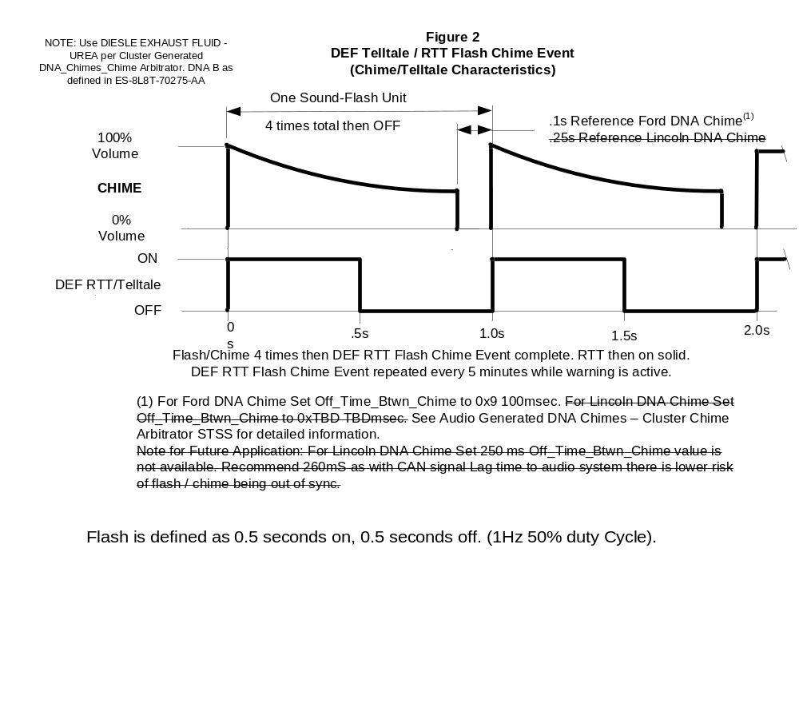

Switch Control Logic

None.

System Accuracy

All Diesel Exhaust Fluid flags shall change within 100msec of a state change as indicated in the state matrix reference 1.3.5.1 Subsystem Algorithm Flowchart/ State Diagram.

Conversions to metric display values shall be as follows:
English Distance (miles) = Metric distance (km) / 1.60934
English speed (MPH) = Metric speed (km/h) / 1.60934

English message text variables are denoted by capitol X or capitol Y. Metric text variables are denoted by lower case x or lower case y. This matches message text list for this feature.

Operation: Performance and Functional

Subsystem Algorithm Flowchart / State Diagram

Figure 3: DID DExx

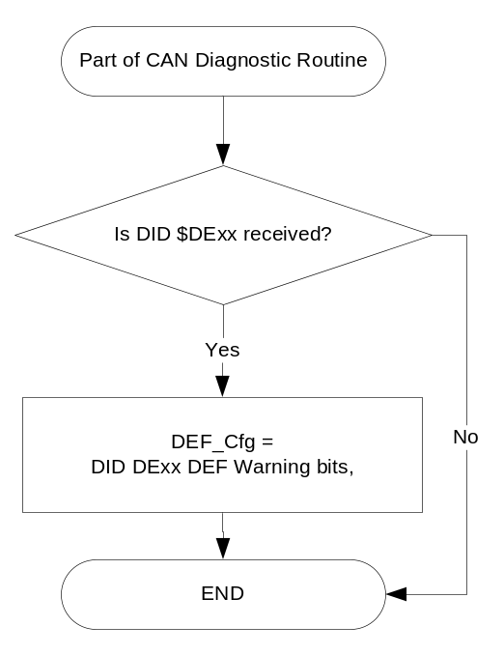

- State Matrix for AdBlue Fixed LED Telltale
Operational  _Mode | DEF_Telltale_Type | DEF_Cfg | ETM_Bulb  _Check_State |  | DIAG_SESSION_TIMER | Self_Test_Entry _Bulb  _Check_ Timer | DIAG_DID_  61A5,4,6  (all warning lamps) | DEF_RTT_TT_Flag
Normal or Crank | Fixed_LED  (0x0) | != Disabled |  | OFF (0x0) | Active | Active | X | On
Normal or Crank | Fixed_LED  (0x0) | != Disabled |  | OFF (0x0) | Active | X | Active | On
Normal or Crank | Fixed_LED  (0x0) | != Disabled |  | ON(0x1) | Not Active | X | X | On
All Other Cases |  |  |  |  |  |  |  | As Per Figure 4

- DEF_Telltale_Type Internal Bit
DEF_Telltale_Type | DEF Telltale | DEF RTT
Fixed_LED (0x0) | On, Off, Flash as per DEF_RTT_TT_Flag | Off
RTT (0x1) | Off | On, Off, Flash as per DEF_RTT_TT_Flag

Figure 4 DEF RTT / DEF TT: Off, On, Flash - Chime Event Control

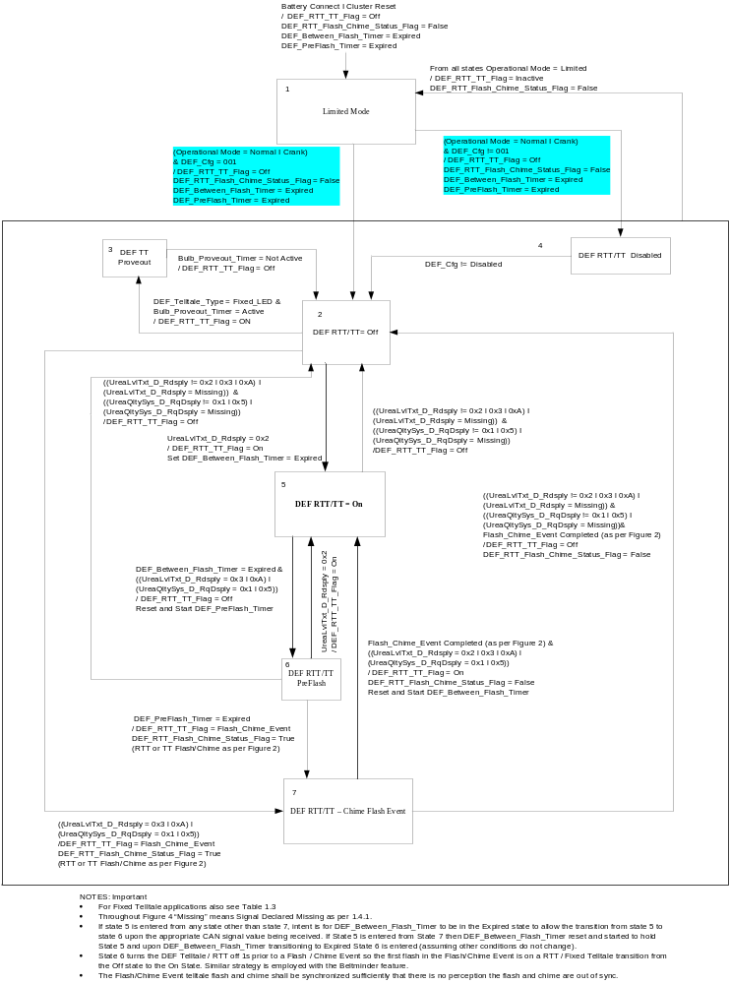

- State Matrix for DEF Level/Fault Warning Flags
Operatinal Mode | Display_Units_MC | UreaLvlTxt_D_RqDsply Signal | UreaQltySys_D_RqDsply | UreaQltyFlg_B_RqDsply | DEF_RTT_TT_ Flag | DEF_Fluid_Low_mi_MC_Status_Flag | DEF_Fluid_ Low_km_MC_Status_Flag | DEF_Fluid_VeryLow_mi_MC_Status_Flag | DEF_Fluid_VeryLow_km_MC_Status_Flag | DEF_Fluid_Empty_NoRestart_EngineIdled_MC_Status_Flag | DEF_Fault_NoRestart_EngineIdled_ mi_MC_Status_Flag | DEF_Fault_NoRestart_EngineIdled_ km_MC_Status_Flag | DEF_Fault_NoRestart_EngineIdled_MC_Status_Flag | DEF_IncorrectAdBlue_NoRestart_EngineIdled_mi_MC_Status_Flag | DEF_IncorrectAdBlue_NoRestart_EngineIdled_km_MC_Status_Flag | DEF_IncorrectAdBlue_NoRestart_EngineIdled_MC_Status  _Flag
Normal or Crank | English (0x0 I 0x1) | 0x2 | 0x0 | X | X | A | I | I | I | I | I | I | I | I | I | I
Normal or Crank | Metric (0x2 I 0x3) | 0x2 | 0x0 | X | X | I | A | I | I | I | I | I | I | I | I | I
Normal or Crank | English (0x0 I 0x1) | 0x3 | 0x0 | X | F | I | I | A | I | I | I | I | I | I | I | I
Normal or Crank | Metric (0x2 I 0x3) | 0x3 | 0x0 | X | F | I | I | I | A | I | I | I | I | I | I | I
Normal or Crank | X | 0xA | 0x0 | X | F | I | I | I | I | A | I | I | I | I | I | I
Normal or Crank | English (0x0 I 0x1) | X | 0x1 | (0X0) l Never Received l Declared Missing per 1.4.1 | F | I | I | I | I | I | A | I | I | I | I | I
Normal or Crank | Metric (0x2 I 0x3) | X | 0x1 | (0X0) l Never Received l Declared Missing per 1.4. | F | I | I | I | I | I | I | A | I | I | I | I
Normal or Crank | X | X | 0x5 | (0X0) l Never Received l Declared Missing per 1.4.1 | F | I | I | I | I | I | I | I | A | I | I | I
Normal or Crank | English (0x0 I 0x1) | X | 0x1 | 0X1 | F | I | I | I | I | I | I | I | I | A | I | I
Normal or Crank | Metric (0x2 I 0x3) | X | 0x1 | 0X1 | F | I | I | I | I | I | I | I | I | I | A | I
Normal or Crank | X | X | 0x5 | 0X1 | F | I | I | I | I | I | I | I | I | I | I | A
All Other Cases |  |  |  |  |  | Inactive

I = Inactive, A = Active

F = DEF_RTT_TT_Flag set to Flash_Chime_Event as per Figure 4

X = Don’t Care
- State Matrix for DEF Min Fill Warning Flags
Operatinal Mode | UreaQltySys_D_RqDsply | UreaMnAdd_L_Actl (if Internal Supplier Config Bit = 0x0)  Or  UreaMnAdd_L2_Actl (if Internal Supplier Config Bit = 0x1) | UreaLvlTxt_D  _RqDsply Signal | DEF_RTT_TT_ Flag | DEF_Fluid_MinRefill  _MC_Status_Flag | DEF_Fluid_Empty  _MinRefill_MC_Status  _Flag
Normal or Crank | 0x0 | != (0x0 l Never Received l Declared Missing per 1.4.1) | (0x2) I (0x3) | F | A | I
Normal or Crank | 0x0 | != (0x0 l Never Received l Declared Missing per 1.4.1) | (0xA) | F | I | A
Normal or Crank | 0x0 | 0x0 l Never Received l Declared Missing per 1.4.1 | X | X | I | I
All Other Cases |  |  |  |  | Inactive

I = Inactive, A = Active

F = DEF_RTT_TT_Flag set to Flash_Chime_Event as per Figure 4

X = Don’t Care

- State Matrix for DEF Level/Fault IOD Flags
Operatinal Mode | Display_Units_MC | Internal Supplier Config Bit (Full Tank DEF Range) | UreaLvlTxt_D_RqDsply Signal | UreaQltySys_D_RqDsply | UreaQltyFlg_B_RqDsply | DEF_Fluid_Ok_IOD_Status_Flag | DEF_Fluid_UnderHalf_IOD_Status_Flag | DEF_Range_mi_IOD_Status_Flag | DEF_Range_km_IOD_Status_Flag | DEF_Fluid_Low_mi_ IOD _Status_Flag | DEF_Fluid_ Low_km_ IOD _Status_Flag | DEF_Fluid_VeryLow_mi_ IOD _Status_Flag | DEF_Fluid_VeryLow_km_IOD_Status_Flag | DEF_Fluid_Empty_NoRestart_EngineIdled_ IOD _Status_Flag | DEF_Fault_NoRestart_EngineIdled_ mi_ IOD _Status_Flag | DEF_Fault_NoRestart_EngineIdled_ km_ IOD _Status_Flag | DEF_Fault_NoRestart_EngineIdled_ IOD _Status_Flag | DEF_IncorrectAdBlue_NoRestart_EngineIdled_mi_IOD_Status  _Flag | DEF_IncorrectAdBlue_NoRestart_EngineIdled_km_IOD_Status  _Flag | DEF_IncorrectAdBlue_NoRestart_EngineIdled_IOD_Status_Flag
Normal or Crank | X | 0x0 | (0x0) | 0x0 | X | A | I | I | I | I | I | I | I | I | I | I | I | I | I | I
Normal or Crank | X | 0x0 | (0x1) | 0x0 | X | I | A | I | I | I | I | I | I | I | I | I | I | I | I | I
Normal or Crank | English (0x0 I 0x1) | 0x1 | (0x0)⁽¹⁾ | 0x0 | X | I | I | A | I | I | I | I | I | I | I | I | I | I | I | I
Normal or Crank | Metric  (0x2 I 0x3) | 0x1 | (0x0)⁽¹⁾ | 0x0 | X | I | I | I | A | I | I | I | I | I | I | I | I | I | I | I
Normal or Crank | English (0x0 I 0x1) | X | (0x2) | 0x0 | X | I | I | I | I | A | I | I | I | I | I | I | I | I | I | I
Normal or Crank | Metric  (0x2 I 0x3) | X | (0x2) | 0x0 | X | I | I | I | I | I | A | I | I | I | I | I | I | I | I | I
Normal or Crank | English (0x0 I 0x1) | X | (0x3) | 0x0 | X | I | I | I | I | I | I | A | I | I | I | I | I | I | I | I
Normal or Crank | Metric  (0x2 I 0x3) | X | (0x3) | 0x0 | X | I | I | I | I | I | I | I | A | I | I | I | I | I | I | I
Normal or Crank | X | X | (0xA) | 0x0 | X | I | I | I | I | I | I | I | I | A | I | I | I | I | I | I
Normal or Crank | English (0x0 I 0x1) | X | X | 0x1 | (0X0) l Never Received l Declared Missing per 1.4.1 | I | I | I | I | I | I | I | I | I | A | I | I | I | I | I
Normal or Crank | Metric (0x2 I 0x3) | X | X | 0x1 | (0X0) l Never Received l Declared Missing per 1.4. | I | I | I | I | I | I | I | I | I | I | A | I | I | I | I
Normal or Crank | X | X | X | 0x5 | (0X0) l Never Received l Declared Missing per 1.4.1 | I | I | I | I | I | I | I | I | I | I | I | A | I | I | I
Normal or Crank | English (0x0 I 0x1) | X | X | 0x1 | 0X1 | I | I | I | I | I | I | I | I | I | I | I | I | A | I | I
Normal or Crank | Metric (0x2 I 0x3) | X | X | 0x1 | 0X1 | I | I | I | I | I | I | I | I | I | I | I | I | I | A | I
Normal or Crank | X | X | X | 0x5 | 0X1 | I | I | I | I | I | I | I | I | I | I | I | I | I | I | A
All Other Cases |  |  |  |  |  | Inactive
I = Inactive, A = Active
F = DEF_RTT_TT_Flag set to Flash_Chime_Event as per Figure 4
X = Don’t Care
- It is understood the 0x1 case will result in All Other Cases. ECM is to never send 0x1 for rows 3 or 4.
Note: C519 program must set Internal Supplier Config Bit (Full Tank DEF Range) = Enabled (0x1). For other new programs check with powertrain representive as to whether the vehicle is equipped with Full Tank DEF DTE (range).
- State Matrix for DEF Min Fill IOD Flags
Operatinal Mode | UreaQltySys_D_RqDsply | UreaMnAdd_L_Actl  (if Internal Supplier Config Bit = 0x0)  Or  UreaMnAdd_L2_Actl  (if Internal Supplier Config Bit = 0x1) | UreaLvlTxt_D_RqDsply Signal | DEF_Fluid_NoFillRqd  _IOD_Status_Flag | DEF_Fluid_MinRefill  _IOD_Status_Flag | DEF_Fluid_Empty_MinRefill  _IOD_Status_Flag | DEF_Fluid_RefillVal_NotAvailable  _IOD_Status_Flag
Normal or Crank | 0x0 | != (0x0 l Never Received l Declared Missing per 1.4.1) | (0x0) l (0x1) | A | I | I | I
Normal or Crank | 0x0 | != (0x0 l Never Received l Declared Missing per 1.4.1) | (0x2) I (0x3) | I | A | I | I
Normal or Crank | 0x0 | != (0x0 l Never Received l Declared Missing per 1.4.1) | (0xA) | I | I | A | I
Normal or Crank | != 0x0 | != (0x0 l Never Received l Declared Missing per 1.4.1) | X | I | I | I | A
Normal or Crank | X | (0x0 l Never Received l Declared Missing per 1.4.1) | X | All Flags Inactive &  DEF Min Fill IOD  Screen Not Displayed

I = Inactive, A = Active,

F = DEF_RTT_TT_Flag set to Flash_Chime_Event as per Figure 4,

X = Don’t Care

All cases for UreaMnAdd_L_Actl/UreaMnAdd_L2_Actl column are covered (all other cases does not apply to UreaMnAdd_L_Actl/ UreaMnAdd_L2_Actl column).

- MC Status Flag to MC Warning Message ID
DEF_Cfg | Active MC_Status_Flag | W# | ACTIVE Chime_Status_  Flag | Ref Text | Message variable values
Disabled | X | None | None |  | Fixed Telltale, RTT, Warnings Message are not active and Info Screens are not Present
001 | DEF_Fluid_Low_mi_MC_Status_Flag | W3264 | Message_Center_Soft_  Warning_  Chime_Status_Flag | AdBlue® Low  Range XXXX mi  Refill Soon | XXXX = VehUreaRnge2_L_DsplyMx (value/1.60934)
001 | DEF_Fluid_ Low_km_MC_Status_Flag | W3265 | Message_Center_Soft_  Warning_  Chime_Status_Flag | AdBlue® Low  Range xxxx km  Refill Soon | xxxx = VehUreaRnge2_L_DsplyMx (value)
001 | DEF_Fluid_VeryLow_mi_MC_Status_Flag | W3266 | DEF_RTT_Flash_  Chime_Status_Flag  Per Figure 2 | AdBlue® Low  No engine start  in XXX mi | XXXX = VehUreaRnge2_L_DsplyMx (value/1.60934)
001 | DEF_Fluid_VeryLow_km_MC_Status_Flag | W3267 | DEF_RTT_Flash_  Chime_Status_Flag  Per Figure 2 | AdBlue® Low  No engine start  in xxxx km | xxxx = VehUreaRnge2_L_DsplyMx (value)
001 | DEF_Fluid_Empty_NoRestart_EngineIdled_MC_Status_Flag | W3268 | DEF_RTT_Flash_  Chime_Status_Flag  Per Figure 2 | AdBlue® Level Empty.  Refill to Start Engine
001 | DEF_Fault_NoRestart_EngineIdled_ mi_MC_Status_Flag | W3269 &  W3270 | DEF_RTT_Flash_  Chime_Status_Flag  Per Figure 2 | AdBlue®sys Malfunction  Service req’d  Then  AdBlue®sys  No engine start in XXXX mi | XXXX = VehUreaRnge2_L_DsplyMx (value/1.60934)
001 | DEF_Fault_NoRestart_EngineIdled_ km_MC_Status_Flag | W3269  &  W3271 | DEF_RTT_Flash_  Chime_Status_Flag  Per Figure 2 | AdBlue®sys Malfunction  Service req’d  Then  AdBlue®sys  No engine start in xxxx km | xxxx = VehUreaRnge2_L_DsplyMx (value)
001 | DEF_Fault_NoRestart_EngineIdled_MC_Status_Flag | W3272 | DEF_RTT_Flash_  Chime_Status_Flag  Per Figure 2 | AdBlue®sys  Service req’d to start engine
001 | DEF_IncorrectAdBlue_NoRestart_EngineIdled_mi_MC  _Status_Flag | W3270  & W3496 | DEF_RTT_Flash_  Chime_Status_Flag  Per Figure 2 | AdBlue®sys  No engine start  in XXXX mi  then  Incorrect AdBlue®  Service Required | XXXX = VehUreaRnge2_L_DsplyMx (value/1.60934)
001 | DEF_IncorrectAdBlue_NoRestart_EngineIdled_km_MC  _Status_Flag | W3271 &  W3496 | DEF_RTT_Flash_  Chime_Status_Flag  Per Figure 2 | AdBlue®sys  No engine start  in xxxx km  then  Incorrect AdBlue®  Service Required | xxxx = VehUreaRnge2_L_DsplyMx (value)
001 | DEF_IncorrectAdBlue_NoRestart_EngineIdled_MC_Status  _Flag | W3272 & W3496 | DEF_RTT_Flash_  Chime_Status_Flag  Per Figure 2 | AdBlue®sys  Service req’d  to start engine  then  Incorrect AdBlue®  Service Required
001 | DEF_Fluid_MaxRefill_MC_Status_Flag | W3490 | No Chime | AdBlue® Level  Max Refill zz L | zz = UreaMxAdd_L_Actl (value)
001 | DEF_Fluid_MinRefill_MC_Status_Flag | W3499 | No Chime | AdBlue® Level  Refill Min (zz or zz.z) L | zz = UreaMnAdd_L_Actl (value)  (if Internal Supplier Config Bit = 0x0)  Or  zz.z = UreaMnAdd_L2_Actl (value)  (if Internal Supplier Config Bit = 0x1)
001 | DEF_Fluid_Empty_MInRefill_MC_Status_Flag | W3493 | No Chime | AdBlue® Level  Empty. Refill  Min (zz or zz.z) L | zz = UreaMnAdd_L_Actl (value)  (if Internal Supplier Config Bit = 0x0)  Or  zz.z = UreaMnAdd_L2_Actl (value)  (if Internal Supplier Config Bit = 0x1)

Notes to above Table:
- Text is REFERENCE ONLY to aid applications engineer understand the function of this system. See the Global Text Message List for apprvoved message text. Advise Ford Driver Info Core Group of any mis-match.

- Expected behavior W3269 and W3270 upon DEF_Fault_NoRestart_or_EngineIdled_ mi_MC_Status_Flag becoming active: W3269 displayes for 2s then W3270 displays for 4s (TA timeout) then W3269 displays for 4s (TA Timeout) for 10s to duration of message texts. This behavior is as per message manager and TA warning message definition. This note applies to all cases where multiple TA warnings are triggered off the same MC_Status_Flag.
- The Info Screens shall not cycle multiple warnings. Only one text per Table 1.5 is shown.
- No chimes are associated with the Info Screens. For the MC Soft Warning the chime is tied to the warning message. For the DEF Telltale / RTT Flash Chime Event the chime is synchronized to the Telltale / RTT flash transition from Off to On.
- TA warnings are now used for all warnings in this text. It is design inent in certain cases to set 2 MC_Status_Flags active simultaneously and it is expected both TA warnings will display for the full 10s. When multiple MC_Status_Flags are set to active simultaneously sequencing must he such that the higher priority message displays first.

- Level/Fault IOD Status Flag to Ixxx Number
DEF_Cfg | Active IOD_Status_Flag | Iod # | Ref Text | Message variable values
Disabled | X | None |  | Fixed Telltale, RTT, Warnings Message are not active and Info Screens are not Present
001 | DEF_Fluid_Ok_IOD_Status_Flag | I523 | AdBlue® Level Ok
001 | DEF_Fluid_UnderHalf_IOD_Status_Flag | I524 | AdBlue® Level Under ½ Full
001 | DEF_Range_mi_IOD_Status_Flag | I551 | AdBlue® Range  XXXXX mi | XXXXX = VehUreaRnge3_L_DsplyMx (value)
001 | DEF_Range_km_IOD_Status_Flag | I552 | AdBlue® Range  XXXXX km | XXXXX = VehUreaRnge3_L_DsplyMx (value)
001 | DEF_Fluid_Low_mi_IOD_Status_Flag | I525 | AdBlue® Low  Range XXXX mi  Refill Soon | XXXX = VehUreaRnge2_L_DsplyMx (value/1.60934)
001 | DEF_Fluid_ Low_km_IOD_Status_Flag | I526 | AdBlue® Low  Range xxxx km  Refill Soon | xxxx = VehUreaRnge2_L_DsplyMx (value)
001 | DEF_Fluid_VeryLow_mi_IOD_Status_Flag | I527 | AdBlue® Low  No engine start  in XXX mi | XXXX = VehUreaRnge2_L_DsplyMx (value/1.60934)
001 | DEF_Fluid_VeryLow_km_IOD_Status_Flag | I528 | AdBlue® Low  No engine start  in xxxx km | xxxx = VehUreaRnge2_L_DsplyMx (value
001 | DEF_Fluid_Empty_NoRestart_EngineIdled_IOD_Status_Flag | I529 | AdBlue® Level Empty.  Refill to Start Engine
001 | DEF_Fault_NoRestart_EngineIdled_ mi_IOD_Status_Flag | I531 | AdBlue® sys  No engine start  in XXXX mi | XXXX = VehUreaRnge2_L_DsplyMx (value/1.60934)
001 | DEF_Fault_NoRestart_EngineIdled_ km_IOD_Status_Flag | I532 | AdBlue® sys  No engine start  in XXXX km | xxxx = VehUreaRnge2_L_DsplyMx (value)
001 | DEF_Fault_NoRestart_EngineIdled_IOD_Status_Flag | I533 | AdBlue®sys  Service req’d to start engine
001 | DEF_IncorrectAdBlue_NoRestart_EngineIdled_mi_IOD  _Status_Flag | I531 | AdBlue® sys  No engine start  in XXXX mi | XXXX = VehUreaRnge2_L_DsplyMx (value/1.60934)
001 | DEF_IncorrectAdBlue_NoRestart_EngineIdled_km_IOD  _Status_Flag | I532 | AdBlue® sys  No engine start  in xxxx km | xxxx = VehUreaRnge2_L_DsplyMx (value)
001 | DEF_IncorrectAdBlue_NoRestart_EngineIdled_IOD  _Status_Flag | I533 | AdBlue®sys  Service req’d to start engine

- Min Fill IOD Screen Flag to Ixxx Number
DEF_Cfg | Active IOD_Status_Flag | Iod # | Ref Text | Message variable values
Disabled | X | None |  | Fixed Telltale, RTT, Warnings Message are not active and Info Screens are not Present
001 | DEF_Fluid_NoFillRqd_IOD_Status_Flag | I571 | AdBlue® Level  No Refill Required
001 | DEF_Fluid_MinRefill_IOD_Status_Flag | I639 | AdBlue® Level  Min Refill (zz or zz.z) L | zz = UreaMnAdd_L_Actl (value)  (if Internal Supplier Config Bit = 0x0)  Or  UreaMnAdd_L2_Actl (value)  (if Internal Supplier Config Bit = 0x1)
001 | DEF_Fluid_Empty_MinRefill_IOD_Status_Flag | I577 | AdBlue® Level  Empty. Refill  Min (zz or zz.z) L | zz = UreaMnAdd_L_Actl (value)  (if Internal Supplier Config Bit = 0x0)  Or  zz.z = UreaMnAdd_L2_Actl (value)  (if Internal Supplier Config Bit = 0x1)
001 | DEF_Fluid_RefillVal_NotAvailable_IOD_Status_Flag | I642 | AdBlue® Level  Refill Amount  Not Available
Notes to above IOD Tables :
- Text is REFERENCE ONLY to aid applications engineer understand the function of this system. See the Global Text Message List for apprvoved message text. Advise Ford Driver Info Core Group of any mis-match.
- No chimes are associated with the IOD display

Operation Description (supports algorithm flowchart /state diagram)
- This feature shall be incorporated on ALL diesel vehicles as per Powertrain direction, however, this feature shall be configured OFF for those diesel applications where local market regulations do not require this feature. This feature is not to be implemented on gas engine vehicles.
- For definition of how the Message Center arbitrates and displays Active warnings, see the Warning / Alert Display Logic Diagram, located in the Message Center – X Display with W Button Interface section of this SPSS (where X and W are appropriate values in this document).
- FNA markets use DEF text messages and North American DEF Symbol. Not covered in this STSS.
- EU markets use AdBlue Text and AdBlue symbol for the RTT/TT. This STSS supports this EU function ONLY.
- FoA markets use AdBlue Text and North American symbol. Not covered in this STSS.
- FSA Chilie/Argentine markets use ARNOX32 Text and North American DEF symbol. Not covered in this STSS.
- If DEF_Telltale_Type = Fixed_LED then DEF_RTT_TT_Flag maps to a fixed LED DEF Telltale. If DEF_Telltale_Type = RTT then DEF_RTT_TT_Flag maps to a DEF RTT.
- The DEF/Adblue symbol (ICON) is intentionally removed from the warning message in the Global text message list to reduce complexity.
- Min Refil warning and Min IOD screens are intended to only be displayed in metric units (litres).
- To meet EEC Reg 692/2008 the DEF (AdBlue) range must be displayed at a minimum of 2400 km to empty. This STSS protects for a range display up to 4095 km.

      - Function Safety Classification (EMC)

Class B

Memory Storage
Parameter Name | Description | Value at  Battery Connect | Value at  Module Wake-up
DEF_Fluid_Low_mi_MC_Status_Flag | Used to control the state of the warning to the Message Center arbitrator | Inactive | Inactive
DEF_Fluid_Low_km_MC_Status_Flag | Used to control the state of the warning to the Message Center arbitrator | Inactive | Inactive
DEF_Fluid_VeryLow_mi_MC_Status_Flag | Used to control the state of the warning to the Message Center arbitrator | Inactive | Inactive
DEF_Fluid_VeryLow_km_MC_Status_Flag | Used to control the state of the warning to the Message Center arbitrator | Inactive | Inactive
DEF_Fluid_Empty_NoRestart_EngineIdled_MC_Status_Flag | Used to control the state of the warning to the Message Center arbitrator | Inactive | Inactive
DEF_Fault_NoRestart_or_EngineIdled_mi_MC_Status  _Flag | Used to control the state of the warning to the Message Center arbitrator | Inactive | Inactive
DEF_Fault_NoRestart_EngineIdled_km_MC_Status_Flag | Used to control the state of the warning to the Message Center arbitrator | Inactive | Inactive
DEF_Fault_NoRestart_EngineIdled_MC_Status_Flag | Used to control the state of the warning to the Message Center arbitrator | Inactive | Inactive
DEF_Fluid_MaxRefill_MC_Status_Flag | Used to control the state of the warning to the Message Center arbitrator | Inactive | Inactive
DEF_IncorrectAdBlue_NoRestart_EngineIdled_mi_MC  _Status_Flag | Used to control the state of the warning to the Message Center arbitrator | Inactive | Inactive
DEF_IncorrectAdBlue_NoRestart_EngineIdled_km_MC  _Status_Flag | Used to control the state of the warning to the Message Center arbitrator | Inactive | Inactive
DEF_IncorrectAdBlue_NoRestart_EngineIdled_MC_Status  _Flag | Used to control the state of the warning to the Message Center arbitrator | Inactive | Inactive
DEF_Fluid_MinRefill_MC_Status_Flag | Used to control the state of the warning to the Message Center arbitrator | Inactive | Inactive
DEF_Fluid_Empty_MInRefill_MC_Status_Flag | Used to control the state of the warning to the Message Center arbitrator | Inactive | Inactive
DEF_Fluid_Ok_IOD_Status_Flag | Used to control the state of the DEF Level/Fault Info Screen | Inactive | Inactive
DEF_Fluid_UnderHalf_IOD_Status_Flag | Used to control the state of the DEF Level/Fault Info Screen | Inactive | Inactive
DEF_Range_mi_IOD_Status_Flag | Used to control the state of the the DEF Info Screen. | Inactive | Inactive
DEF_Range_km_IOD_Status_Flag | Used to control the state of the the DEF Info Screen. | Inactive | Inactive
DEF_Fluid_Low_mi_IOD_Status_Flag | Used to control the state of the DEF Level/Fault Info Screen | Inactive | Inactive
DEF_Fluid_Low_km_IOD_Status_Flag | Used to control the state of the DEF Level/Fault Info Screen | Inactive | Inactive
DEF_Fluid_VeryLow_mi_IOD_Status_Flag | Used to control the state of the DEF Level/Fault Info Screen | Inactive | Inactive
DEF_Fluid_VeryLow_km_IOD_Status_Flag | Used to control the state of the DEF Level/Fault Info Screen | Inactive | Inactive
DEF_Fluid_Empty_NoRestart_EngineIdled_IOD_Status  _Flag | Used to control the state of the DEF Level/Fault Info Screen | Inactive | Inactive
DEF_Fault_NoRestart_EngineIdled_mi_IOD_Status_Flag | Used to control the state of the DEF Level/Fault Info Screen | Inactive | Inactive
DEF_Fault_NoRestart_EngineIdled_km_IOD_Status_Flag | Used to control the state of the DEF Level/Fault Info Screen | Inactive | Inactive
DEF_Fault_NoRestart_EngineIdled_IOD_Status_Flag | Used to control the state of the DEF Level/Fault Info Screen | Inactive | Inactive
DEF_IncorrectAdBlue_NoRestart_EngineIdled_mi_IOD  _Status_Flag | Used to control the state of the DEF Level/Fault Info Screen | Inactive | Inactive
DEF_IncorrectAdBlue_NoRestart_EngineIdled_km_IOD  _Status_Flag | Used to control the state of the DEF Level/Fault Info Screen | Inactive | Inactive
DEF_IncorrectAdBlue_NoRestart_EngineIdled_IOD  _Status_Flag | Used to control the state of the DEF Level/Fault Info Screen | Inactive | Inactive
DEF_Fluid_NoFillRqd_IOD_Status_Flag | Used to control the state of the DEF Min/Max Info Screen | Inactive | Inactive
DEF_Fluid_MaxRefill_IOD_Status_Flag | Used to control the state of the DEF Min/Max Info Screen | Inactive | Inactive
DEF_Fluid_MinRefill_IOD_Status_Flag | Used to control the state of the DEF Min/Max Info Screen | Inactive | Inactive
DEF_Fluid_Empty_MinRefill_IOD_Status_Flag | Used to control the state of the DEF Min/Max Info Screen | Inactive | Inactive
DEF_Fluid_RefillVal_NotAvailable_IOD_Status_Flag | Used to control the state of the DEF Min/Max Info Screen | Inactive | Inactive
DEF_RTT_Flash_Chime_Status_Flag | Used to control the state of the chime to the Chime Arbitrator | Inactive | Inactive
Message_Center_Informational_Chime_Status_Flag | Used to control the state of the chime to the Chime Arbitrator | Inactive | Inactive
DEF_RTT_TT_Flag | Flag used to control the state of the DEF RTT or TT as equipped. Also input used to enable the re-occurring TA warnings.  States: Off, On, Flash_Chime_Event | Off | Off
DEF_RTT_Flash_Chime_Status_Flag | A state indicator to determine if DIESEL EXHAUST FLUID – UREA chime shall sound in sync with flashing Diesel Exhaust Fluid telltale. | See Audio Generated DNA Chimes – Cluster Chime Arbitrator latest level.
DEF_Telltale_Type | Internal supplier bit that defines type of telltale used. States: Fixed_LED (0x0), RTT (0x1). | Use Stored Value | Use Stored Value
VehUreaRnge2_L_DsplyMx signal | CAN signal sent from the ECM | 0 (0x0) | 0 (0x0)
VehUreaRnge3_L_DsplyM signal | CAN signal sent from the ECM | 0 (0x0) | 0 (0x0)
UreaLvlTxt_D_RqDsply signal | CAN signal sent from the ECM | 0 (0x0) | 0 (0x0)
UreaQltySys_D_RqDsply | CAN signal sent from the ECM | 0 (0x0) | 0 (0x0)
UreaQltyFlg_B_RqDsply | CAN signal sent from the ECM | 0 (0x0) | 0 (0x0)
UreaMnAdd_L_Actl | CAN signal sent from the ECM | 0 (0x0) | 0 (0x0)
UreaMnAdd_L2_Actl | CAN signal sent from the ECM | 0 (0x0) | 0 (0x0)
Display_Units_MC | Flag used to indicate English or Metric unit choice. See Display Unit Selection Control Function STSS.
DEF_Cfg | Encoded indicator of feature presence and local market function controlled via CAN at EOL at VO plant. | Use Stored Value | Use Stored Value
Internal Supplier Config Bit (Full Tank DEF Range) | Internal supplier bit to enable/disable Full Tank DEF DTE (range). | Use Stored Value | Use Stored Value
Internal Supplier Config Bit (UreaMinAdd signal) | Internal supplier bit to indicate either zz or zz.z for min refill IOD/warning. | Use Stored Value | Use Stored Value
Operational_Mode | 4 state indicator for cluster operational mode. | Limited | Limited, Normal, or Crank
Bulb_Provout_Timer | Timer used to control Bulb (telltale) Proveout. States: Not Active or Active | See Bulb Prove Out Function STSS
DEF_Between_Flash_Timer | Timer used to control Flash_Chime_Events and display of TA warnings. | As Per Figure 4
DEF_PreFlash_Timer | Timer used to turn off the DEF telltale 1s prior to a Flash_Chime_Event | As Per Figure 4

Parameter Name | Description | Range | Units | Resolution | Init Value
DEF_Between_Flash_Timer | Timer used as an input to control the DEF_RTT_TT_Flag | 180 – 360 | Seconds | 60 | 180
DEF_PreFlash_Timer | Timer used as an input to control the DEF_RTT_TT_Flag | N/A | Seconds | N/A | 1
DEF_PreFlash_Timer matches current practice for Beltminder to turn the telltale off briefly prior to flash chime event.

Prove Out
Fixed LED Telltale - Yes
RTT - No

Reconfigurable Telltale

Fixed or RTT

Message Center Msg

See Table 1.5

Error Handling

Missing Message Strategy

The signals will be declared missing as per the Diagnostics section of this SPSS.

DTCs states and history will be determined as per the Diagnostics section of this SPSS.

Diagnostics

Self Test

None

Engineering Test Mode

Fixed Telltale illumination only as per Table 1.3

Part II Performance

DID $DExx:
Block  Num | Block Description | Byte(s) | Bits | State: Description | "0" | "1" | Default | Comments/  Information
PACKETED BLOCKS
$00 | Option  Content (B&A) | * | * | DEF Warnings | encoded | encoded | 000 | Not Dealer Configurable
 |  |  |  | 000– Disabled | encoded | encoded
 |  |  |  | 001 – AdBlueTxt / DEF Telltale | encoded | encoded |  | DEF telltale as per 11/15/2016 is now common global symbol. AdBlue telltale no longer used. This configuration applies to all markets using AdBlue Text.
 |  |  |  | 010 – ARNOX32 Txt / DEF Telltale | encoded | encoded |  | Chile, Argentina Software to be treated as 000
 |  |  |  | 011 – AdBlue Txt / AdBlue Telltale | encoded | encoded |  | EU Markets
 |  |  |  | 100 – DEF Text / DEF Telltale | encoded | encoded |  | U.S., Canada, Mexico  Software to be treated as 000
 |  |  |  | 101 - 111 | encoded | encoded |  | Software to be treated as 000
*Byte and bit location to be identified in Part II Specification for this cluster

Reference Specification

IS-0001 WARNINGS/INDICATORS/DISPLAYS PROVEOUT
IS-0052 OPERATING VOLTAGES - FUNCTIONAL/PERFORMANCE
IS-0069 FUNCTIONAL IMPORTANCE CLASS
IS-0324 WINDSHIELD & OTHER REFLECTIONS
IS-0327 WARNING INDICATOR EVALUATION
IS-0379 NORTH AMERICAN WARNINGS AND INDICATORS STRATEGY

IL-0017 TELLTALE AND INTERIOR ILLUMINATION – COLOR AND INTENSITY
IL-0019 GENERAL ILLUMINATION DIMMING
IL-0021 CRAFTSMANSHIP – DISPLAYS
IL-0022 GENERAL ILLUMINTATION COLOR
IL-0023 CLARITY/LEGIBILITY/READABILITY/VISUAL CONTRAST
IL -0043 OPERATIONAL ENVIRONMENT FUNCTIONALITY
IL -0045 COLOR
IL -0047 TELLTALE, INDICATOR AND DISPLAY LIGHT INTENSITY
IL -0048 ILLUMINATION ACCEPTABILITY

03-0661 PLACEMENT: CONTROL AND DISPLAY LOCATIONS
03-0662 PLACEMENT: LOGICAL GROUPING FUNCTION AND USAGE
03-0664 PLACEMENT: DOWN VISION TO COMPONENTS WITH HIGH VISUAL DEMAND
03-0665 PLACEMENT: EXPECTED LOCATIONS OF CONTROLS AND DISPLAYS VDS
03-0670 INTERIOR VISIBILITY
03-0671 INTERIOR VISIBILITY: REFLECTIONS FROM COMPONENTS & SURFACES
03-0672 INTERIOR VISIBILITY: REFLECTIONS IN DISPLAYS
03-0673 INTERIOR VISIBILITY: VISUAL OBSCURATIONS
03-0674 INTERIOR VISIBILITY: ILLUMINATION CONTROLS / DISPLAYS
03-0675 INTERIOR VISIBILITY: VEILING GLARE
03-0677 INTERIOR VISIBILITY: SUNLIGHT WASHOUT
03-0681 IDENTIFICATION: CHARACTER AND SYMBOL SIZE
03-0682 IDENTIFICATION: LEGIBILITY
03-0685 IDENTIFICATION: SYMBOLS, ABBREV FOR CONTROL
03-0721 LOGIC OF OPERATION: OPERATIONAL STEREOTYPES
03-0722 LOGIC OF OPERATION: INTERPRETATION
03-0723 LOGIC OF OPERATION: USE OF SYSTEMS WITH VISUAL DISPLAYS

Revision History
SPSS Module Revision History

Revision Level | Name | Change Description | Date
1.0 | J.Blatchford | Initial Release | 6/25/14
2.0 | J. Blatchford | Intent of this change is to add minimum and maximum AdBlue fill to values. It is intentional that all values are only displayed in metric units. It also changes the reoccurring warnings so they return every 3 minutes instead of 5 minutes. Changes this version in red.  - 1.1: Updated added signals.  - Figure 1: Added signals.  - Table 1.3: Added Table.  - Table 1.4: Added Table.  - 1.2.3: Added MC and IOD flags.  - Table 1.8: Added Table.  - Table 1.10: Added Table.  - Table 1.11: Added flags. Added note under table.  - Table 1.13: Added Table.  - 1.3.5.4: Added Flags. Changed DEF_Between_Flash_Timer Init Value from 300 seconds to 180 seconds. | 10/31/14
2.1 | J. Blatchford | This change only updates the 2.0 revision row to include the DEF_Between_Flash_Timer init Value change. No functional change to STSS. | 11/2/2014
2.2 | J. Blatchford | Per EEC Reg 692/2008 DEF (AdBlue) range must be displayed at a minimum of 2400 km to empty. This update changes the range signal from VehUreaRnge_L_DsplyMx which contains 11 bits to VehUreaRnge2_L_DsplyMx which contains 12 bits and is able to support a max range display of 4045 km.  Changes highlighted in yellow except for Figure 1.  - 1.1: Changed signal name.  - Figure 1: Updated signal name.  - Table 1.0: Updated as appropriate for the new signal.  - Table 1.1: Updated signal name in multiple cases.  - Table 1.12: Updated signal name in multiple cases.  - 1.3.5.2: Added note.  - 1.3.5.4: Updated signal name. | 4/15/2015
2.3 | Ilopezla | This update is to add Message_Center_Soft_Warning_Chime_Status_Flag (all changes are highlighted in light blue)  Section 1.2.1 Figure 1 Added-Message_Center_Soft_Warning_Chime_Status_Flag and DEF_RTT_Flash_Chime_Status_Flag  Section 1.2.3 Added Message_Center_Soft_Warning_Chime_Status_Flag and DEF_RTT_Flash_Chime_Status_Flag  Section 1.3.3.2 Correct Table reference.  Section 1.3.5 Updated Table 1.11  Replaced ”Chime” with “Active Chime_Status_Flag”  Replaced ”Soft Warning” with “Message_Center_Soft_Warning_Chime_Status_Flag”. Add DEF_RTT_Flash_Chime_Status_Flag  Section 1.3.5.4 Added Message_Center_Soft_Warning_Chime_Status_Flag and DEF_RTT_Flash_Chime_Status_Flag to Memory Storage Table | 1/13/2016
3.0 | J. Blatchford | This update adds Full Tank AdBlue DTE (range), adds capability for the min refill warnings and IOD to display in tenths of a liter, and adds Incorrect AdBlue text which is an upcoming regulatory requirement for AdBlue. The Full Tank DEF DTE indicates DEF range from full tank down to the point where regulated inducement starts. Intent during this non-regulated indication is to decrement full DEF DTE (range) in blocks of 100km or 100mi. See functional description for more details. The min refill warnings display the minimum amount of AdBlue that must be added to get the system out of inducement. The incorrect AdBlue warnings are displayed when the operator fills the AdBlue(DEF) tank with poor quality AdBlue or some fluid other than AdBlue. All changes highlighted in green.  - 1.1: Added new signals and parameters required. Added descriptive paragraph on Full Tank DEF DTE.  - Figure 1: Updated context diagram.  - 1.2.1 Added internal supplier config bit and new signals (Table 1.1, Table 1.4, Table 1.5). Removed (crossed out) UreaMxAdd_L_Actl signal as it is no longer used.  - 1.2.3 Added MC_Status_Flag(s) and IOD_Status_Flags to support new function. Crossed out Max refill flags as that feature is no longer supported.  - Table 1.9 Updated to add new functionality.  - Table 1.10: Updated to remove max fill warning and replace with min refill.  - Table 1.11: Updated to support new function – Full Tank DEF DTE and Min Refill warnings.  - Table 1.12: Updated to remove max refill and display min refill for that signal value.  - Table 1.13: Updated to add Incorrect AdBlue flags and added W#s.  - Table 1.14: Updated and added IOD flags and associated I#s.  - Table 1.15: Removed Max Refill IOD row. Added capability to display tenths of a liter.  - 1.3.5.4: Added new flags and variables associated with this change. | 5/5/2016
3.1 | J. Blatchford | Corrected minor error in that minimum refill needs to be 3 digits (tens, ones, tenths) not 2 digits. Change not highlighted.  - Table 1.13 Modified W3499 & 3493 rows z.z→zz.z  - Table 1.15 Modified I689 &I577 rows z.z→zz.z | 5/6/2016
1.0 | J. Blatchford | Initial Release – From AdBlue Level and System Fault Warnings with RTTorFixed TT EU Specific CGEA1.3 v3.1. Updated to be S-Family IPC specific for 2018 V362MCA/C519. This is program specific because it must support both UreaMnAdd_L_Actl (old) and UreaMnAdd_L2_Actl (new) signals. This is because ECM has a different phase in plan for the new signal causing IPC complexity. Going forward only the new signal will be supported.  As per 11/20/2016 DI Change Control direction is to no longer use the AdBlue telltale and replace it with the global DEF telltale (F.027). This update also changes Adblue telltale to DEF telltale as per that direction. As a result the DEF Warnings configuration is changed to reflect this.  - Updated title to be program specific.  - 1.1: Updated to add UreaMnAdd_L_Actl (herein old signal) and paragraph to describe why this STSS is program specific.  - Figure 1: Updated to add old signal back in and Internal Supplier Config bit.  - 1.2.2: Added Internal Supplier bit and old signal.  - 1.3.3.1.1: Updated to ROW F.27 DEF symbol.  - Figure 4: Updated configuration to 001 (AdBlue Text /DEF Telltale.  - Table 1.10, 1.12,: Updated to add internal config bit to support both old and new signals.  - Table 1.13: Updated DEF_Cfg configuration to 001 and added internal config bit to support both old and new symbols  - Table 1.14: Updated DEF_Cfg configuration to 001 and added internal config bit to support both old and new symbols  - 1.3.5.4: Added internal supplier configuration bit and old signal back in.  - 1.5.3: Updated to 001. Added description of why this update was made. | 11/21/2016
1.1 | J. Blatchford | This update corrects and issue that has existed since release of v3.0 where in row 4 of Table 1.11 UreaLvlTxt_D_RqDsply Signal column, 0x1 is entered where per recent powertrain clarification that should be 0x0. Change is in yellow.  - Table 1.11: Corrected row 4 as described. Added note (1) below Table to address recent Q&A where supplier did not understand design intent. | 9/11/2017

